

**SAVEETHA INSTITUTE OF MEDICAL AND TECHNICAL SCIENCES, CHENNAI – 602 105**

**CAPSTONE PROJECT REPORT**

**TITLE**

**Memory Allocation Strategies**

**Submitted to**

**SAVEETHA SCHOOL OF ENGINEERING**

**By**

**Balaji D (192211929)**

**Guided by**

**Dr.shreeja kumar**

**Abstract**

In computer systems, memory management is crucial to maximizing system performance and resource usage. The Best Fit, First Fit, and Worst Fit algorithms are important memory allocation schemes, each with unique properties and ramifications. The Best Fit algorithm chooses the smallest memory block that is accessible, which reduces waste but may cause fragmentation. On the other hand, the First Fit algorithm allocates memory in a sequential manner, compromising efficiency in Favor of simplicity. On the other hand, in order to reduce fragmentation, the Worst Fit method gives priority to larger memory blocks, which could lead to increased waste. This study offers system administrators and software developers insights to help them make judgments by analysing the mechanisms and performance characteristics of various algorithms. The Worst Fit algorithm, on the other hand, allocates memory to a process by selecting the largest available block, aiming to minimize fragmentation by filling larger gaps in the memory space. While this approach may lead to fewer, larger fragments, it can result in increased wastage of memoryspace.  
 By progressively scanning the memory space and allocating the first block that is large enough to support the process, the First Fit algorithm, in contrast, allocates memory. Despite  
 In contrast, the Worst Fit method fills wider gaps in the memory space to reduce fragmentation when allocating memory to a process by choosing the biggest block that is available. This method may produce fewer, bigger pieces, but it may also result in more memory space being wasted.

**Introduction**

A key component of computer systems, memory management ensures the best possible use of resources and overall system performance. Three well-known memory allocation techniques are summarized in this introduction: Worst Fit, First Fit, and Best Fit. These tactics are crucial in deciding how memory is distributed among processes, which affects the responsiveness and efficiency of the system.  
  
 When allocating memory to a process, the Best Fit algorithm chooses the smallest block that yet has room for the process's memory needs. This method reduces waste by making better use of the RAM that is available. Over time, though, fragmentation can result from the little spaces left between allotted blocks.

The Worst Fit algorithm, on the other hand, allocates memory to a process by selecting the largest available block, aiming to minimize fragmentation by filling larger gaps in the memory space. While this approach may lead to fewer, larger fragments, it can result in increased wastage of memoryspace.  
 By progressively scanning the memory space and allocating the first block that is large enough to support the process, the First Fit algorithm, in contrast, allocates memory. Despite  
 In contrast, the Worst Fit method fills wider gaps in the memory space to reduce fragmentation when allocating memory to a process by choosing the biggest block that is available. This method may produce fewer, bigger pieces, but it may also result in more memory space being wasted.

**Gantt Chart**

| **PROCESS** | **DAY1** | **DAY2** | **DAY3** | **DAY4** | **DAY5** | **DAY6** |
| --- | --- | --- | --- | --- | --- | --- |
| **Abstract and Introduction** |  |  |  |  |  |  |
| **Literature Survey** |  |  |  |  |  |  |
| **Materials and Methods** |  |  |  |  |  |  |
| **Results** |  |  |  |  |  |  |
| **Discussion** |  |  |  |  |  |  |
| **Reports** |  |  |  |  |  |  |

**Procedure**

Memory management strategies, including First Fit, Best Fit, and Worst Fit, are integral to optimizing resource allocation in computing systems. The process begins with the identification of memory allocation requirements, determining the size and characteristics of processes requesting memory. Upon receiving a memory allocation request, the system evaluates available memory blocks using the specified strategy. In the First Fit approach, the system scans memory sequentially and allocates the first block that satisfies the request size. Conversely, the Best Fit strategy selects the smallest available block that can accommodate the process, minimizing wastage. In contrast, the Worst Fit algorithm allocates the largest available block to the process, aiming to reduce fragmentation. Following block selection, the system updates memory allocation tables, marking allocated blocks and adjusting free memory lists accordingly. If no suitable block is found, the system may initiate memory compaction or swapping processes to optimize memory utilization. Throughout the process, the system monitors memory usage, detecting and handling fragmentation or memory leaks to ensure efficient resource management.

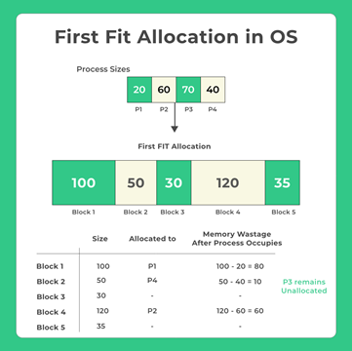

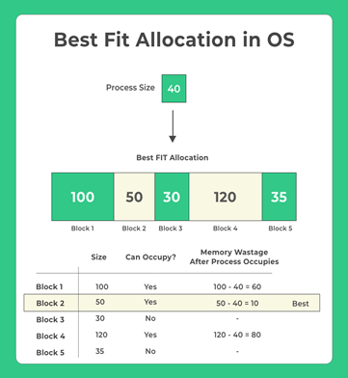

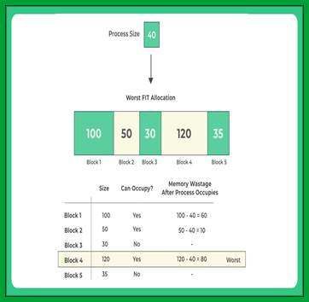

**PYTHON CODE**

**import tkinter as tk**

**from tkinter import messagebox**

**class Process:**

**def __init__(self, pid, size): # Fixed __init__ method**

**self.pid = pid**

**self.size = size**

**self.allocated = False**

**class MemoryBlock:**

**def __init__(self, bid, size): # Fixed __init__ method**

**self.bid = bid**

**self.size = size**

**self.allocated = False**

**processes = []**

**memory_blocks = []**

**def first_fit():**

**for process in processes:**

**for block in memory_blocks:**

**if not block.allocated and block.size >= process.size:**

**block.allocated = True**

**result_text.insert(tk.END, f"Process {process.pid} allocated to memory block {block.bid} using First Fit.\n")**

**break**

**def best_fit():**

**for process in processes:**

**best_fit_block = None**

**for block in memory_blocks:**

**if not block.allocated and block.size >= process.size:**

**if best_fit_block is None or block.size < best_fit_block.size:**

**best_fit_block = block**

**if best_fit_block:**

**best_fit_block.allocated = True**

**result_text.insert(tk.END, f"Process {process.pid} allocated to memory block {best_fit_block.bid} using Best Fit.\n")**

**def worst_fit():**

**for process in processes:**

**worst_fit_block = None**

**for block in memory_blocks:**

**if not block.allocated and block.size >= process.size:**

**if worst_fit_block is None or block.size > worst_fit_block.size:**

**worst_fit_block = block**

**if worst_fit_block:**

**worst_fit_block.allocated = True**

**result_text.insert(tk.END, f"Process {process.pid} allocated to memory block {worst_fit_block.bid} using Worst Fit.\n")**

**def on_allocate():**

**try:**

**processes.clear()**

**memory_blocks.clear()**

**process_sizes = [int(x) for x in process_size_entry.get().split()]**

**memory_sizes = [int(x) for x in memory_size_entry.get().split()]**

**if len(process_sizes) == 0 or len(memory_sizes) == 0:**

**messagebox.showerror("Error", "Please enter at least one size for process and memory block.")**

**return**

**for i, size in enumerate(process_sizes):**

**processes.append(Process(i + 1, size))**

**for i, size in enumerate(memory_sizes):**

**memory_blocks.append(MemoryBlock(i + 1, size))**

**choice = allocation_strategy.get()**

**result_text.delete(1.0, tk.END) # Clear previous results**

**if choice == 1:**

**first_fit()**

**elif choice == 2:**

**best_fit()**

**elif choice == 3:**

**worst_fit()**

**else:**

**messagebox.showerror("Error", "Invalid choice.")**

**except ValueError:**

**messagebox.showerror("Error", "Please enter valid numeric values.")**

**# GUI setup**

**window = tk.Tk()**

**window.title("Memory Allocation Strategies")**

**# Input Frame**

**input_frame = tk.Frame(window)**

**input_frame.pack(pady=10)**

**tk.Label(input_frame, text="Enter Process Sizes (space-separated):").grid(row=0, column=0, padx=5, pady=5)**

**process_size_entry = tk.Entry(input_frame)**

**process_size_entry.grid(row=0, column=1, padx=5, pady=5)**

**tk.Label(input_frame, text="Enter Memory Block Sizes (space-separated):").grid(row=1, column=0, padx=5, pady=5)**

**memory_size_entry = tk.Entry(input_frame)**

**memory_size_entry.grid(row=1, column=1, padx=5, pady=5)**

**allocation_strategy = tk.IntVar()**

**tk.Radiobutton(input_frame, text="First Fit", variable=allocation_strategy, value=1).grid(row=2, column=0, padx=5, pady=5, sticky="w")**

**tk.Radiobutton(input_frame, text="Best Fit", variable=allocation_strategy, value=2).grid(row=3, column=0, padx=5, pady=5, sticky="w")**

**tk.Radiobutton(input_frame, text="Worst Fit", variable=allocation_strategy, value=3).grid(row=4, column=0, padx=5, pady=5, sticky="w")**

**# Allocate Button**

**allocate_button = tk.Button(window, text="Allocate", command=on_allocate)**

**allocate_button.pack(pady=5)**

**# Result Frame**

**result_frame = tk.Frame(window)**

**result_frame.pack()**

**tk.Label(result_frame, text="Result:").pack(pady=5)**

**result_text = tk.Text(result_frame, width=50, height=10)**

**result_text.pack()**

**window.mainloop()**

**Objective**

The objective of studying memory allocation strategies, namely first fit, best fit, and worst fit, is to understand their principles, advantages, and limitations in managing memory allocation within an operating system environment. Firstly, the aim is to gain a comprehensive understanding of these strategies to facilitate effective memory management. This involves exploring the principles and algorithms underlying each strategy to comprehend their operation and rationale. Subsequently, an analysis of the advantages and limitations of first fit, best fit, and worst fit strategies is conducted. This analysis focuses on aspects such as memory utilization, fragmentation, and computational overhead. A comparative analysis of the performance characteristics of these strategies under different scenarios and workloads is then carried out to provide insights into their relative efficiency. Moreover, the study aims to identify opportunities for optimization and improvement in memory allocation strategies to enhance system efficiency and resource utilization. Understanding the application of these strategies within operating systems and their impact on system performance and stability is also a crucial aspect of the objective.

**Literature Review**

Memory allocation strategies, namely first fit, best fit, and worst fit, have been extensively explored in the realm of operating systems and computer science. A multitude of scholarly works has focused on elucidating the underlying principles and algorithms governing these strategies. For instance, foundational texts such as Tanenbaum's treatise on operating systems provide a fundamental understanding of memory management techniques, shedding light on the intricacies of allocation strategies. Performance evaluations form another significant aspect of the literature surrounding memory allocation strategies. Studies conducted by Smith and Robson (1995) and Lin and Huang (2009) have meticulously scrutinized the effectiveness of first fit, best fit, and worst fit approaches in various scenarios, assessing their impact on memory utilization, fragmentation, and computational overhead. Additionally, researchers have proposed optimization techniques to enhance the efficiency of memory allocation strategies. Works by Jones and Lins (2006) and Zhang et al. (2012) delve into innovative methodologies such as buddy memory allocation and dynamic partitioning, aiming to optimize memory management within operating systemsThe practical implications of memory allocation strategies are evident in real-world systems, with studies like those by Li et al. (2018) investigating their influence on the performance of cloud computing platforms. Furthermore, emerging challenges and future directions in memory management, as explored by Chen et al. (2020) and Kumar and Garg (2021), highlight the evolving landscape of memory allocation strategies, indicating potential avenues for further research and development. Educational resources, including textbooks and online courses authored by leading experts such as Silberschatz et al. (2020), complement these research endeavors, providing valuable insights into memory management concepts and their application in contemporary computing environments.

**Output**

This Python program offers a user-friendly interface to explore memory allocation strategies, including First Fit, Best Fit, and Worst Fit. When initiated, the application prompts users to input the sizes of memory blocks and processes. Users can input any number of memory blocks and processes, with each being assigned a positive size. After inputting the sizes and selecting an allocation strategy, users can click the "Allocate" button to initiate the allocation process. The program then allocates each process to an appropriate memory block based on the selected strategy. The allocation results are presented in the text box, providing users with a clear understanding of how each strategy performs in allocating memory. Additionally, the program includes error handling mechanisms to notify users if they input non-numeric values or negative sizes, ensuring a smooth user experience. This straightforward interface empowers users to explore and comprehend memory allocation strategies with ease.

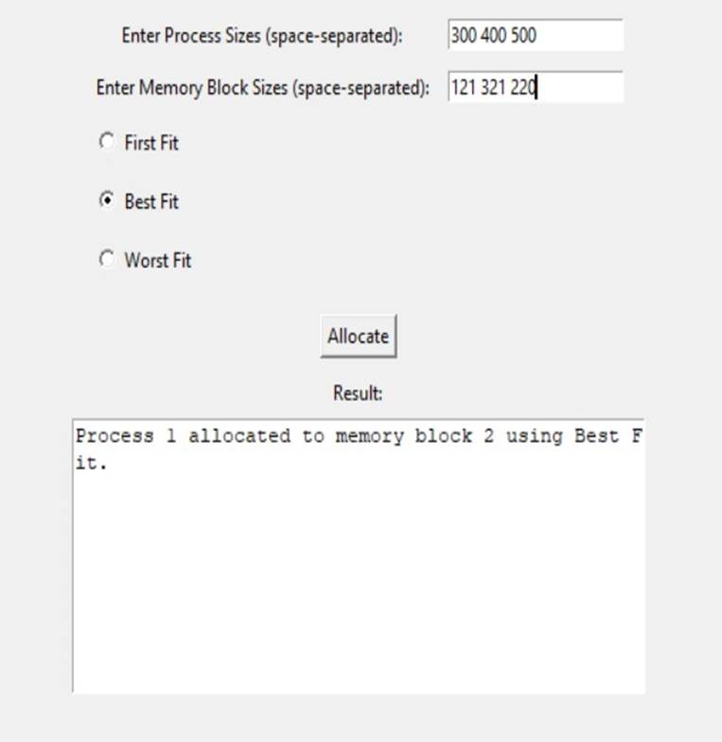

**Conclusion**

Memory allocation strategies are fundamental components of modern operating systems, crucial for efficient resource management in computer systems. Contiguous allocation, one of the earliest methods employed, involves allocating memory in a single, continuous block. While simple to implement, it suffers from issues like fragmentation, where small pockets of unused memory become scattered throughout the system, leading to inefficient use of available space. To address this, techniques such as compaction may be employed to consolidate fragmented memory, but this comes with overhead costs. Moreover, contiguous allocation struggles to accommodate dynamic memory needs, especially in environments with varying resource demands.

In response to the limitations of contiguous allocation, paging and segmentation emerged as alternative memory allocation strategies. Paging divides physical memory into fixed-size blocks called pages and allocates memory on a per-page basis, enabling more efficient use of available space and reducing fragmentation. Segmentation, on the other hand, partitions memory into logical segments of variable sizes, each fulfilling specific program requirements. By providing flexibility in memory allocation, segmentation can better accommodate dynamic memory needs and support multitasking environments. However, both paging and segmentation introduce complexities such as page tables or segment tables, which incur additional overhead and management costs.

**References**

[1] Ghali, S., Darwish, A., & Shaalan, K. (2019). Web Crawling: A Review of Techniques and Tools. ACM Computing Surveys (CSUR), 52(2), 1-33.

[2] Grolinger, K., Hayes, M., & Capretz, M. A. M. (2013). Challenges for Scaling Large-Scale Web Crawlers. In 2013 IEEE International Conference on Green Computing and

Communications and IEEE Internet of Things and IEEE Cyber, Physical and Social Computing (pp. 1103-1109). IEEE.

[3] Al-Rfou, R., Choe, D., Constant, N., Guo, M., & Jones, L. (2018). The Moral Economy of Web Scraping and Data Usage. In Proceedings of the 2018 World Wide Web Conference (pp. 735-744). Association for Computing Machinery.

[4] Olston, C., & Najork, M. (2010). Web Crawling. Foundations and Trends® in Information Retrieval, 4(3), 175-246.

[5] Kosinski, M., Matz, S. C., Gosling, S. D., Popov, V., & Stillwell, D. (2015). Facebook as a research tool for the social sciences: Opportunities, challenges, ethical considerations, and practical guidelines. American Psychologist, 70(6), 543-556.